Student Name: __________________
Class and Section __________________
Total Points (20 pts) __________________
Due: March 3, 2010 before the class

Project: Selection Sort Animation

CSCI 2410 Data Structures and Algorithms
Armstrong Atlantic State University

Problem Description:

Write a Java applet that animates the selection sort algorithm. Create an array that consists of 20 distinct numbers from 1 to 20 in a random order. The array elements are displayed in a histogram, as shown in the following figure. Clicking the Step button causes the program to perform an iteration of the outer loop in the algorithm and repaints the histogram for the new array. Color the last bar in the sorted subarray. When the algorithm is finished, display a dialog box to inform the user. Clicking the Reset button creates a new random array for a new start. (You can easily modify the program to animate the insertion algorithm.) Name the applet Exercise24_15.

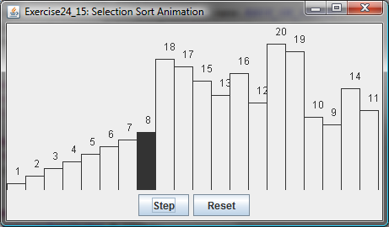

Design (Draw the UML diagram of the classes for the project)

Coding (Insert source code here)

Sample runs (Screen shots of sample runs)

What to submit?

- Fill in this Word file and print a copy.
- Compile and Submit to LiveLab (you must submit the program regardless whether it complete or incomplete, correct or incorrect)

